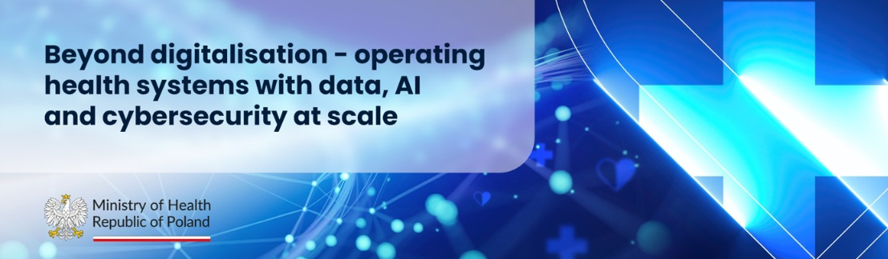
PRACTICAL INFORMATION NOTE
for Participants
21-23 September 2026, Warsaw
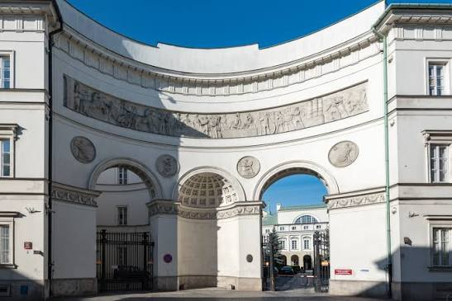

Table of Contents

Meeting information and agenda 3
Delegation format 4
Working language of the meeting and interpretation 4
Registration 4
Venue of the meeting 5
Transport 6
Accommodation 6
Catering 7
Visas 7
Facilities 7
Conference on the Internet 7
Social event 8
Practical information 8

Meeting information and agenda
Date / time | Programme
21 September  18:00-22:00 | Opening evening  Opening of the conference  Welcome remarks: Jolanta Sobierańska-Grenda, Minister of Health  Keynote speech and group photo  Networking dinner
22 September  09:30-17:30 | AI & Cybersecurity  Track A | Governing AI in Health Systems: A1. Beyond AI Pilots: What Is Required to Scale AI Across Health Systems; A2. Interoperability as a Foundation for AI at Scale; A3. Towards a European Agenda for AI in Health.  Lunch  Track B | Cybersecurity as Health Security: B1. Cybersecurity as a Core Health System Function; B2. Protecting Critical Health Infrastructure; B3. Building Resilient Health Systems Through Cyber Preparedness.  Warsaw High Level Dialogue on the Future of Health Systems  Networking sightseeing
23 September  10:00-15:00 | Governance and resilience  • Building Resilient Health Systems in an Era of Continuous Disruption  • From Digitalisation to Data-Driven Health System Governance  • Building Resilient Health Systems: Finances, Investments and Governance  • Digital Health Governance Between Politics, Evidence and Public Expectations  Closing Remarks and Lunch

Delegation format
2 delegates from each country.
Recommended format is high level experts on digital health and/or international cooperation.

Working language of the meeting and interpretation
The meeting will be held in English with simultaneous translation/interpretation into Russian and Polish provided.

Registration
Each participant is requested to register on: Poland4DigitalHealth – Akademia CeZ.
Photographs and videoclips will be taken during the meeting and social event. By attending this meeting, you give your consent.
All personal data provided during the accreditation process is processed in accordance with the EU General Data Protection Regulation (GDPR).

DEADLINE
All participants are kindly requested to register before 14 September.

BADGES
After successful registration, badges will be available at the dedicated reception desk at the Novotel Warszawa Centrum Hotel before departure to a dinner.
For those arriving later, badges will be available at the entrance to the Ministry of Health before a dinner. However, bear in mind that this procedure can be longer.
For those arriving later or not attending a dinner in the Ministry of Health, badges will be available at the entrance to the e-Health Center.
Be kindly encouraged to wear badges in a visible place throughout the meeting.

Venue of the meeting
21 September – official opening of the meeting - a dinner in the Ministry of Health

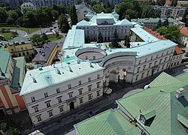
Pac Palace, the seat of the Ministry of Health of the Republic of Poland, is a late Neoclassical palace featuring four wings and two courtyards, one of which has the rare form of a circular courtyard.
The palace was built between 1681 and 1687 in the Baroque style and remained the property of the Radziwiłł family for most of its history until the beginning of the 19th century. In 1823, the palace was purchased by General Ludwik Michał Pac, for whom it was extensively rebuilt. Since then, it has been known as Pac Palace.
The palace was partially destroyed during the Second World War and was reconstructed between 1948 and 1951.
From 1918 to 1939, the building housed the Warsaw Regional Court (District Court). Since 1951, it has served as the headquarters of the Ministry of Health of the Republic of Poland.

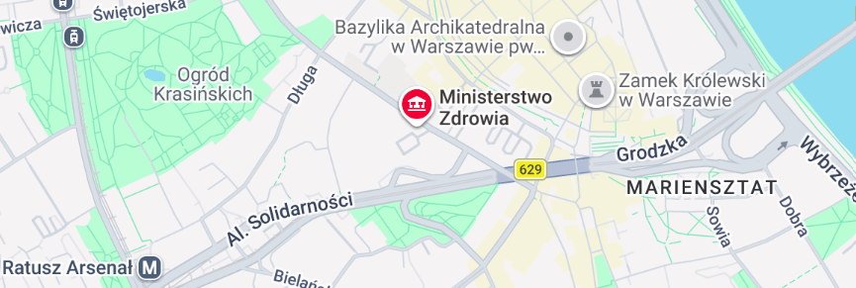
Address:
Miodowa Str. 15
Warsaw

22 and 23 September – a conference in the e-Health Centre

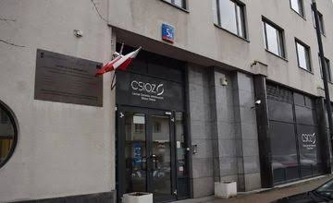
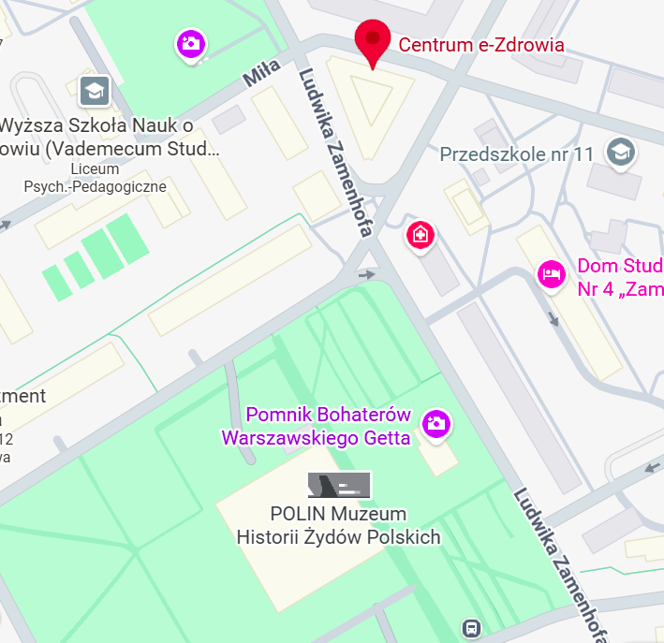
Address: 5A Stanisława Dubois

Transport
Ministry of Health provides a bus transfer between Novotel Warszawa Centrum Hotel and the Ministry of Health (21 September) and e-Health Centre (22 and 23 September).
Moreover, it is possible to use Warsaw public transport or taxis.

FROM THE AIRPORT TO THE CENTRE OF WARSAW
You can find the transfer options from the airports to the city centre here:
- from Warsaw Chopin Airport to the city centre: https://www.lotnisko-chopina.pl/en/public-transport.html.
- from Warsaw Modlin Airport to the city centre: https://en.modlinairport.pl/page/train

Accommodation
We recommend Novotel Warszawa Centrum Hotel (94/98, Marszałkowska Str., Warsaw; https://all.accor.com/hotel/3383/index.pl.shtml) where accommodation for one person per delegation will be covered by the Ministry of Health of Poland.
For voucher to the hotel, please contact us at: beyond.digitalisation@mz.gov.pl.

Catering
An official opening dinner on 21 September will be hosted by the Minister of Health of Poland.
Lunches on 22 and 23 September will be provided by the Ministry of Health of Poland.
Coffee, tea and cold beverages and small snacks will be available at the e-Health Centre during the meetings.

Visas
Please check with your travel agent if a visa is required for your travel to Poland. If so, kindly apply for one as soon as possible. The letter of invitation to participate in the conference should facilitate the issuance of your visa.
If there are any issues we can support you with, please contact on: beyond.digitalisation@mz.gov.pl.

Facilities
Wi-fi will be available on the premises of the Ministry of Health and e-Health Centre.
The password will be provided during the meetings.

Please, be informed that the Ministry of Health as a historical site is not accessible easily for persons with limited mobility.
The e-Health Centre is fully adapted to the needs of persons with disabilities.
If you have special needs related to disabilities, please contact the meeting hosts.

Conference on the Internet
Poland4DigitalHealth – Akademia CeZ

Social event
The Ministry of Health of Poland is pleased to invite you to attend the social event in the Norblin Museum (https://muzeumfabrykinorblina.pl/en/norblin-factory-museum/).
Guided tours will be conducted in English and Russian.

Practical information
Emergency number: 112 (fire brigade, police)
Emergency medical number: 999
Electricity: the voltage in Poland is 230 V, 50 Hz.
Local time: Central European summer time zone (CEST) - GMT +2:00
Area code: +48
Currency: The official currency of Poland is the Polish zloty. Official daily exchange rates can be found on the website of the National Bank of Poland: https://nbp.pl/en/statistic-and-financial-reporting/rates/.
ATM machines are available at main banks, airports, shopping centers and throughout the city, and most venues accept major credit cards.
Weather in Poland: https://meteo.imgw.pl/
Tap water: Polish tap water is regularly tested in terms of quality, and it is safe to drink, https://www.warszawskakranowka.pl/en/

